Task-Create a report in Microsoft Word and answer the following questions...

1. **What are three conclusions we can make about Kickstarter campaigns given the provided data?**

Conclusion 1: Music Kickstarter Campaigns have the highest chance to succeed in crowdfunding.

Among all countries, Theater related campaigns have the highest number of all Kickstarter projects, which are mostly contributed by Plays funding campaigns (see figure 2). Following are Music and Film & Video, ranking the 2nd and the 3rd respectively in terms of campaign numbers (see figure 1).

However, Music campaigns are the most profitable Kickstarter projects (see figure 3), with 100% success rate of classical, electronic, pop and rock music fundings (see figure 4). Also, it is worth mentioned that hardware and documentary have high positive outcomes (see figure 2).

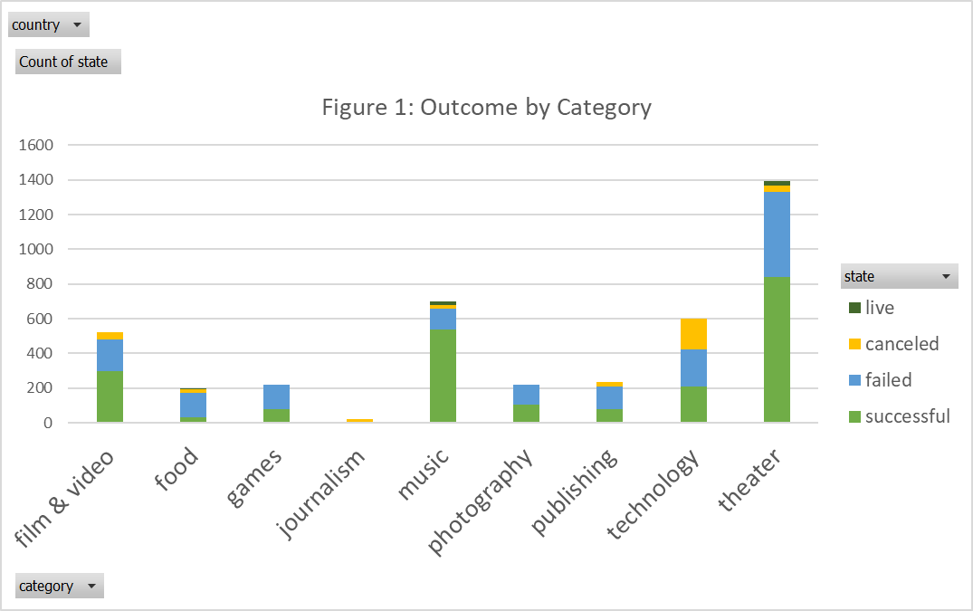

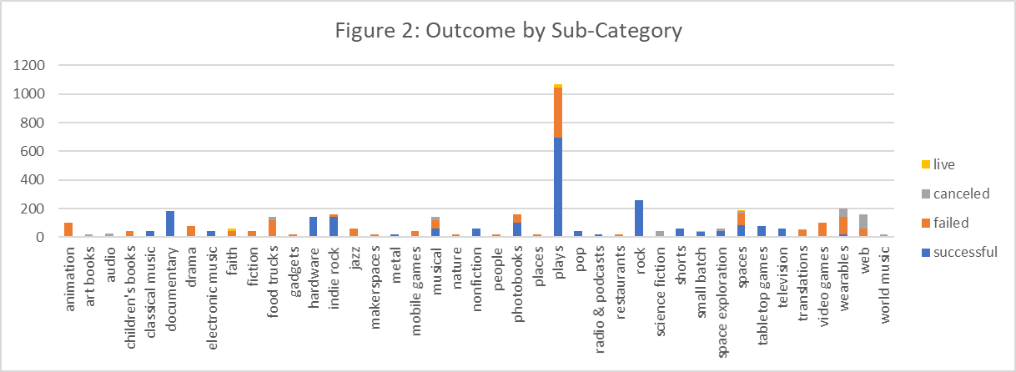

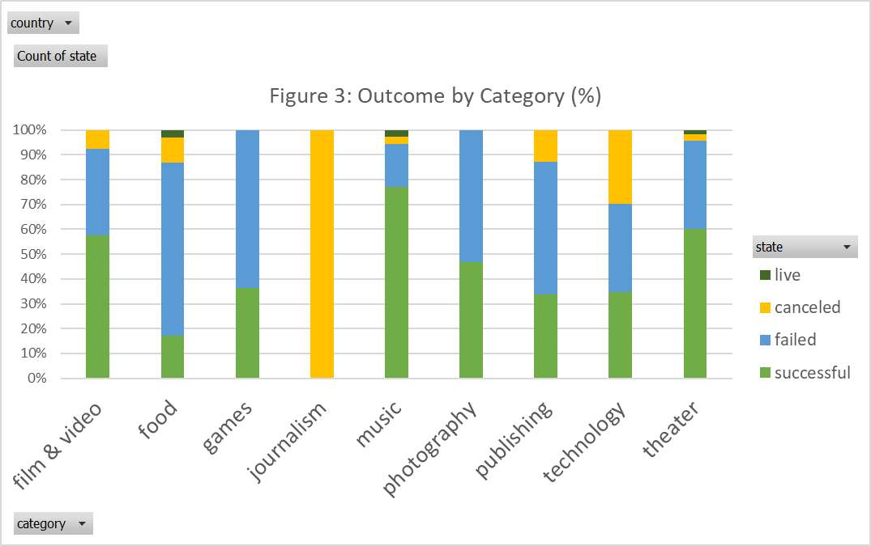

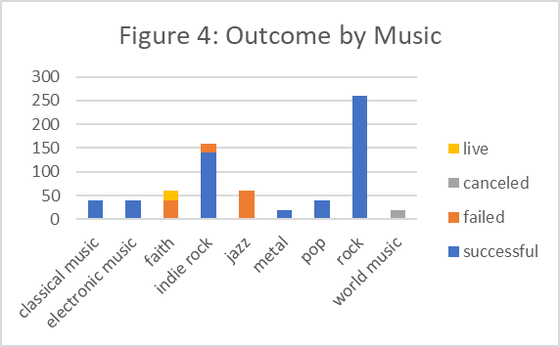

Conclusion 2: On the other hand, games and food campaigns are more likely to end with negative outcomes (see figure 3).

This is because food trucks and video/mobile games tends to fail in Kickstarter fund raising (see figure 5&6).

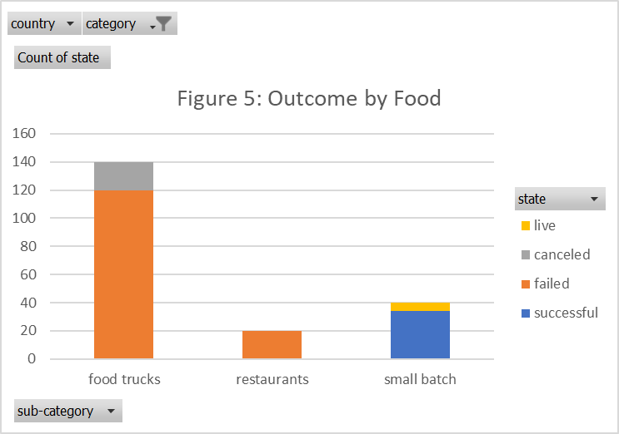

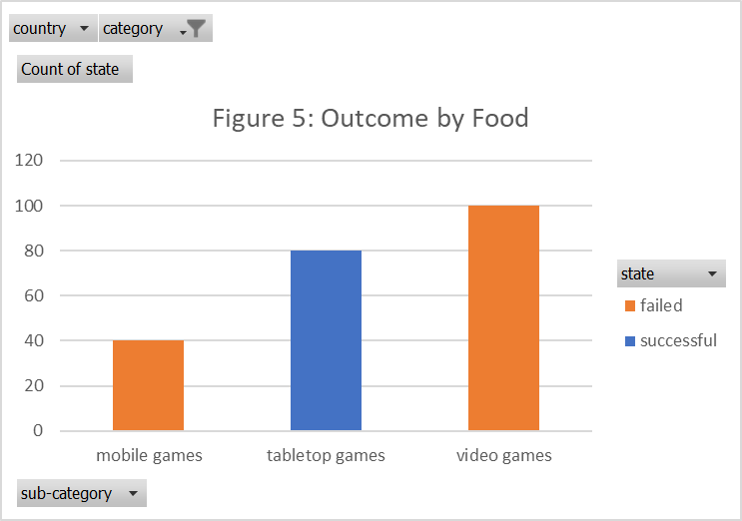

Conclusion 3: Campaigns launched on December tend to have higher risks based on the previous year’s performance (see figure 7), especially in year 2014-2016.

Holiday seasons and budgets can be one of the reasons that cause less positive outcomes of crowdfunding.

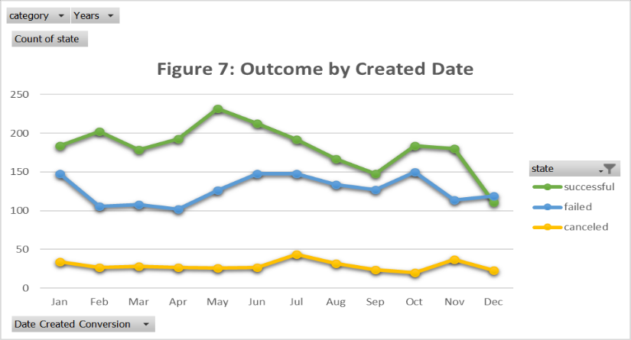

1. **What are some of the limitations of this dataset?**

* One limitation is the goal settings. The “state” and “percentage funded” results are based on the “pledged” compared with “goals”. However, some goals are set randomly and thoughtlessly, such as “1” or “100 million”. This might result in limitations in analyzing outcomes of campaign fund raising.
* Another limitation is the bias by different countries. This dataset is in a large scale generated by US, Great Britain and Canada campaigns (see figure 8), which might indicates biased preference and can not be adopted by decision makes from other countries.

1. **What are some other possible tables/graphs that we could create?**

* One of the tables can be created would be the percentage of positive outcomes by different countries (see Table 1, see figure 9). From the table and map, we can see that Great Britain and US have relatively high success rate in Kickstarter funding.



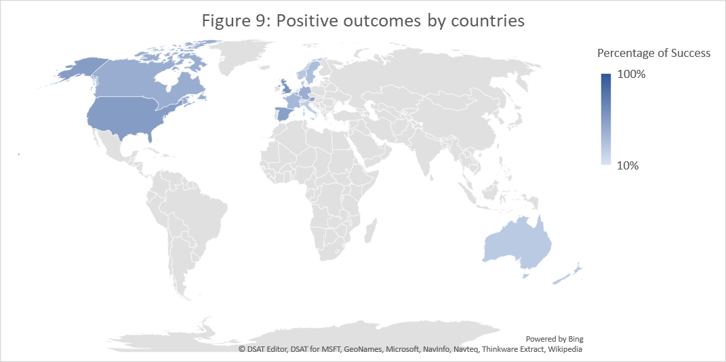

* Another interesting result I found is that games and technology campaign have relative high percentage funded, despite less success rate to reach their goals (see Table 2 and figure 10). This is mainly because tabletop games and hardware has surprisingly high funding results compare to the goals.



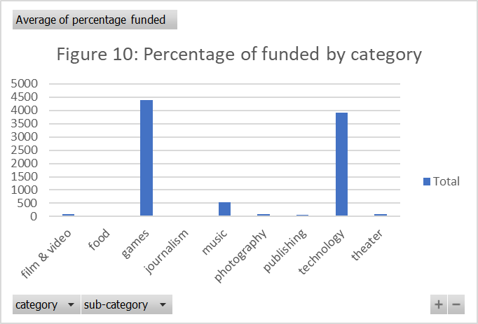

* Besides, analysis shows that campaigns picked by staff are more likely to reach their goals (see figure 11).

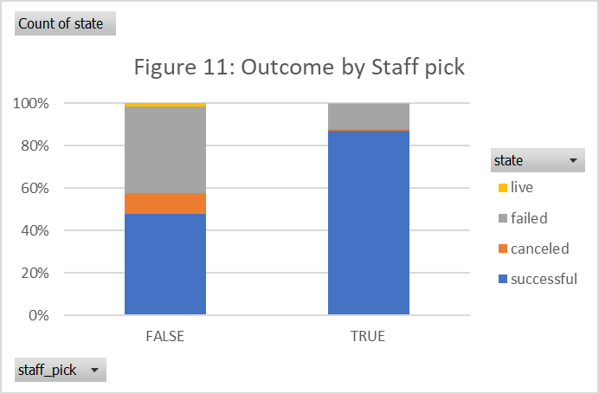

* Additionally, US donator tend to spend more on the campaigns they are interested in, compared to the rest of the world. This can be shown by the highest average of percentage of funded in US (see figure 12).

